Simply Fit Master

**Team:** Kae Bauder, William Larson, Steven Montgomery, Diego Moya-Kolarovski

**Target Platform:** Computer

**Task Analysis:** [Task Analysis V1](https://docs.google.com/document/d/1vgvR0-TauR1gtNbRUR3LUzbvqUCtj1LrvyH66ay8CeE/edit?usp=sharing)

**Published Design:** [Published Design](https://overlyencumbered.github.io/)

**Team GitHub account:** [Team GitHub](https://github.com/OverlyEncumbered/OverlyEncumbered.github.io)

**1. Simply Fit Homepage**

Users will first land on the home page. It has the application's goal as well as links in the top left to different web pages with different features.

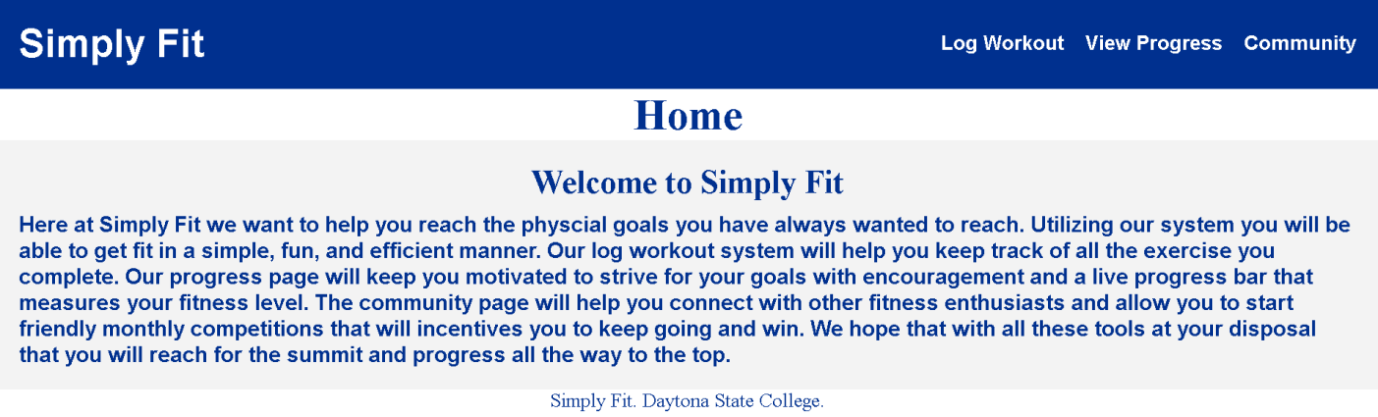

**2. Log Workout Page**

User click Log Workout Menu

User enters Exercise Name, Sets, Reps, Duration

Click Log Workout button when ready

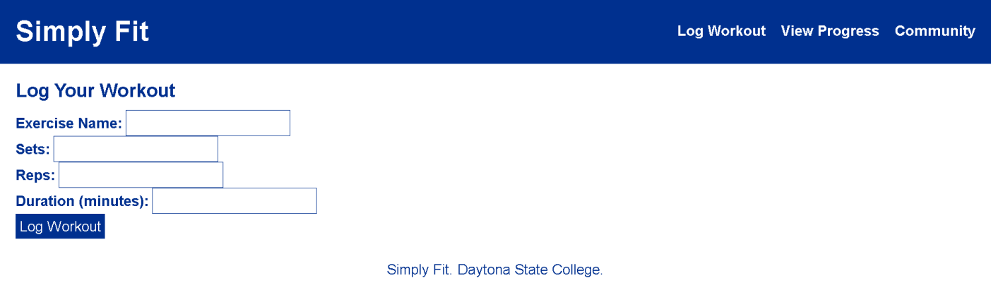

When user clicks Log Workout button, then Previous Logs will display

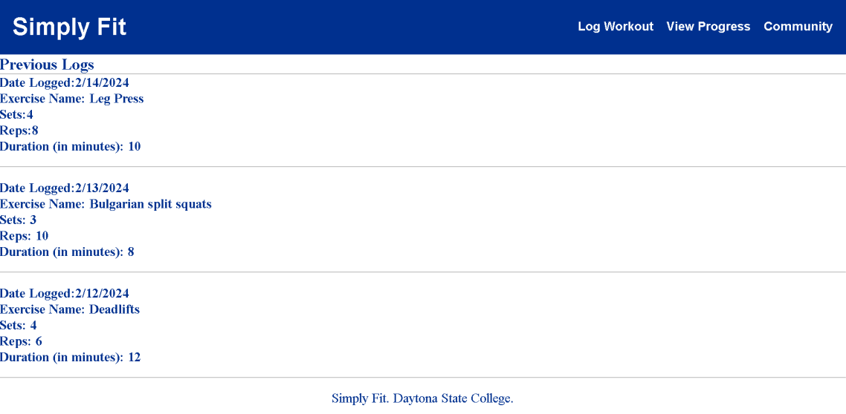

**3. View Progress page**

User clicks “View Progress” menu

A progress bar representing Fitness Level shows where you are compared to your goal. The goal is self set by the user.

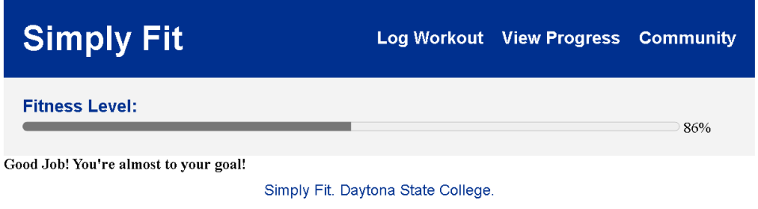

**4. Community Page**

User clicks “Community” from the menu at the right top side. This brings them to the community page which allows them to search for other users. By clicking the monthly competition button they are able to view the monthly leaderboards.

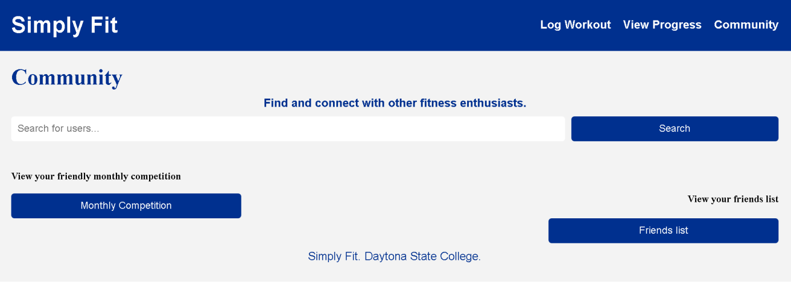

User click “Friends List”

This opens up the individuals “Friends List” and allows them to view their friends and compare statistics.

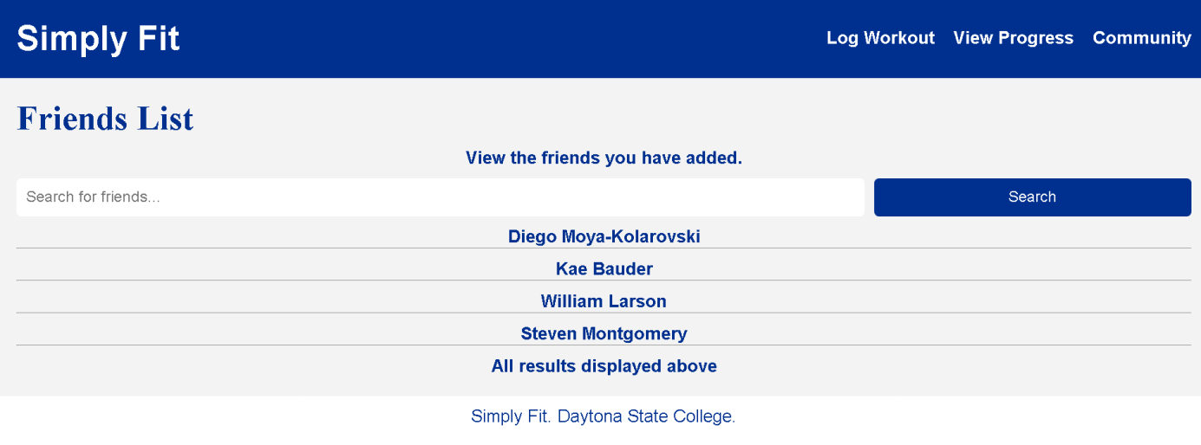

User enters friend’s name in “Search for friends…” box

When “Monthly Competition” is clicked

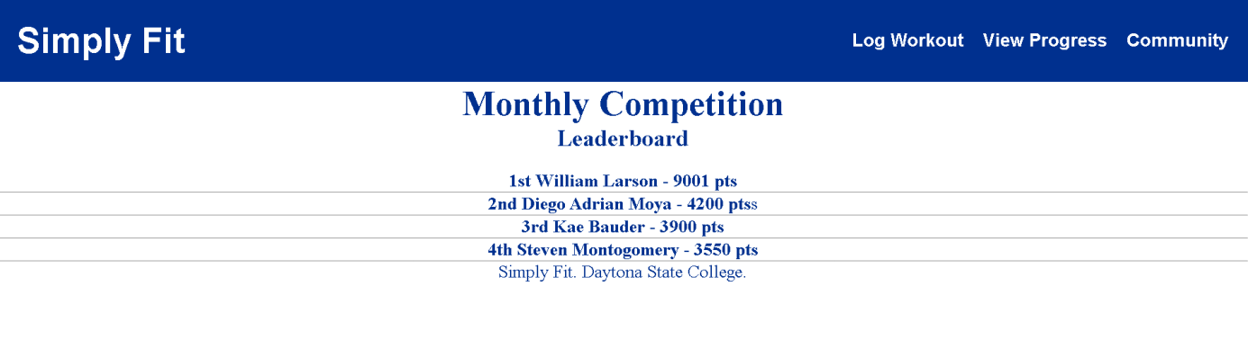

This allows them to view the current monthly competition. It scores soldiers based on a points system. The points are calculated based on workout, sets, repetitions, etc.